EduShield

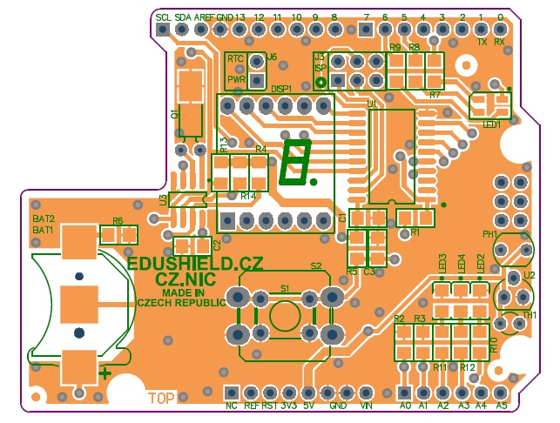

Použité piny na Arduino
D2: Button
D3: RTC SQW out
D4: ---
D5: RGB LED: G
D6: RGB LED: B
D7: ---
D8: ---
D9: RGB LED: R
D10: ---
D11: ---
D12: ---
D13: Green LED
A0(D14): Light sensor
A1(D15): Temperature sensor
A2(D16): Red LED
A3(D17): Green LED
A4(D18): DS1307 SDA pin
A5(D19): DS1307 SCK pin

