WI-FI User Guide
- Brief Introduction
Main Chip | ESP8266
Frequency | 2.412GHz~2.484GHz
Module Voltage | 5V
Working Current | 50mA
Peak Current | 300mA
Hardware Output | UART Serial Port
Default Baud Rate | 9600Bd
Working Mode | STA + AP

2. Hardware Introduction
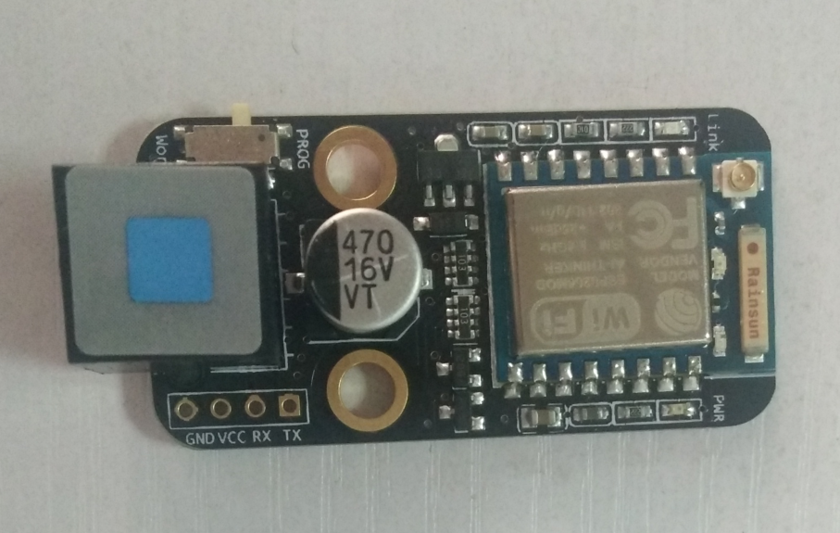
Power Indicator 1
Power Indicator 2
DIY Interface
Status Switch
Receiving Indicator接收指示灯
Link Indicator
External Antenna Interface
Indicators
After the Wi-Fi module is connected the main board, the red power indicator 1 and 2 will be on. About 1 second later, the blue link indicator will start flashing, which means the module has started normally (but not connected to any mobile devices yet).
If it’s connected to a device and has successfully accomplished data transfer for one time, the link indicator will be solid on. Meanwhile, the blue receiving indicator will keep flashing when the module is receiving data.
Status Switch
By flipping the status switch, you can choose Work or PROG working mode. Work means normal working status (regular status) while PROG refers to programming.

3. How to Use
3.1 Configuration Setting
1) Connect your computer to the Wi-Fi hotspot. 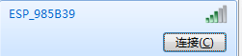
(Note: no password by default).
2) Open your browser and enter 192.168.4.1.
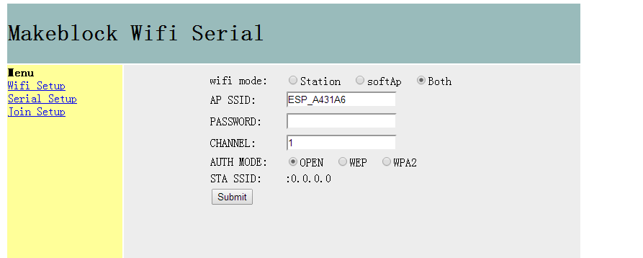
Diagram1
In Wi-Fi Setup page, you can set the SSID, password, etc.
- AP SSID: Set the name you want to use for this Wi-Fi Module
- Password: set a password you want or leave it blank.

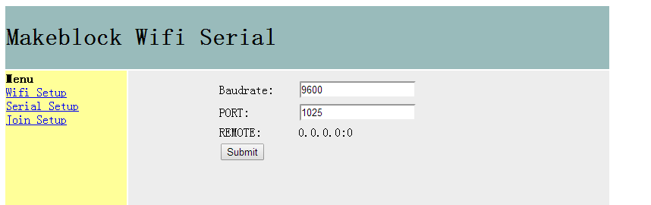
Diagram 2
In Serial Setup page, you can set the baud rate and port number.
Baudrate: the serial baud rate for communicating with the main control board.
Port: Set the port number. (It’s not recommended setting the port number as 333 since it’s the broadcast number).
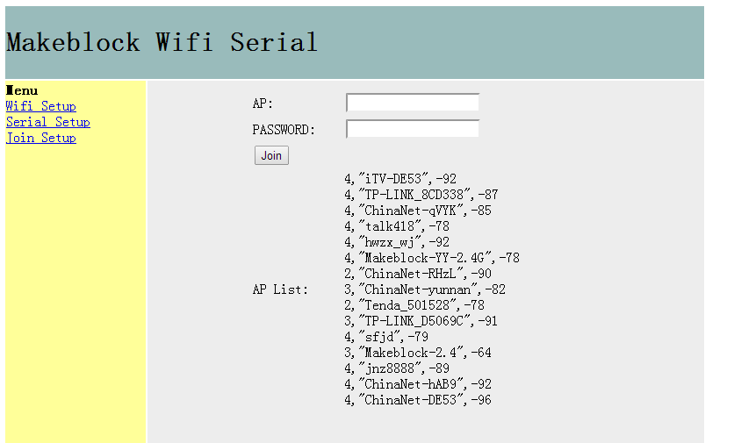
Diagram 3
In Join Setup page, you can select the network you want, then enter the name and its password.
AP: Copy/enter the name of the network you want to connect to. (You can see all the Wi-Fi names the Wi-Fi module has found in the AP list)
Password: Enter the password of the network you choose.

3.2 Connect PC to Wi-Fi Module
AP mode refers to hotspot mode which requires no router connection.
Open software USR-TCP232-TesT, and make sure your computer has already connected to the Wi-Fi generated by the Wi-Fi module before opening the software.

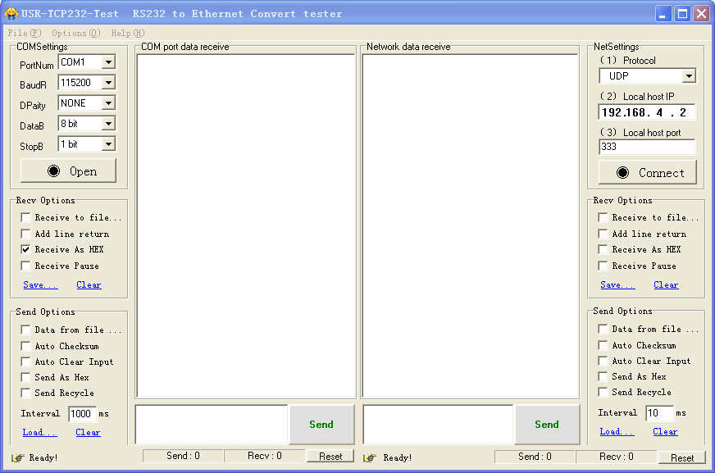
Choose “UDP” in Protocol at the to-right corner, and then Connect
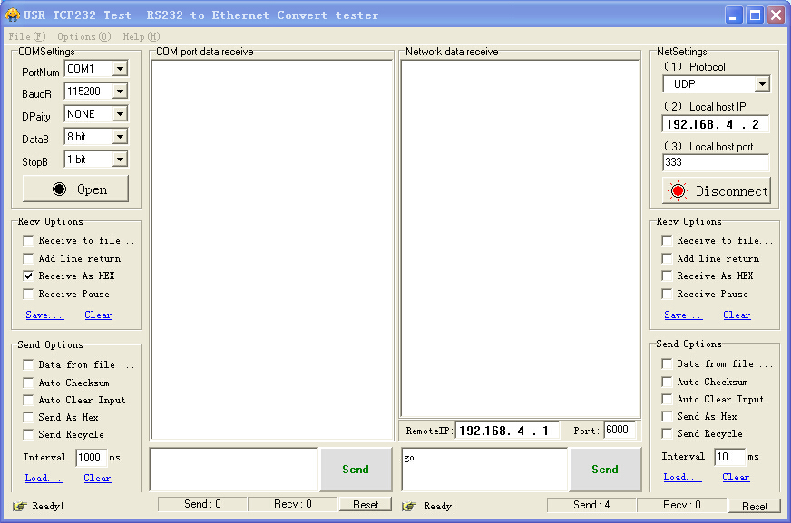
Enter 192.168.4.1 for RemoteIP;
Enter the port number you set in Serial Setup page (Diagram 2) for Port

In the meantime, write the following program in Arduino
#include <Makeblock.h>
#include <Arduino.h>
#include <SoftwareSerial.h>
#include <Wire.h>

MeWifi Wifi(PORT_4);

void setup()
{
Serial.begin(9600);
Wifi.begin(9600);
Serial.println("Bluetooth Start!");
}

void loop()
{
char inDat;
char outDat;
if(Wifi.available())
{
char c = Wifi.read();
Serial.print(c);

}
if(Serial.available())
{
outDat = Serial.read();
Wifi.write(outDat);
}
}
Open the Arduino serial port to realize Wi-Fi passthrough, hence to receive and send data.
In STA mode, the Wi-Fi module needs to be mounted to a nearby router (as shown in Diagram 3). After successful connection of the Wi-Fi module and the router, the router will assign IP address automatically. (Check the IP address in STA SSID from Wi-Fi Setup page as shown in Diagram 1)
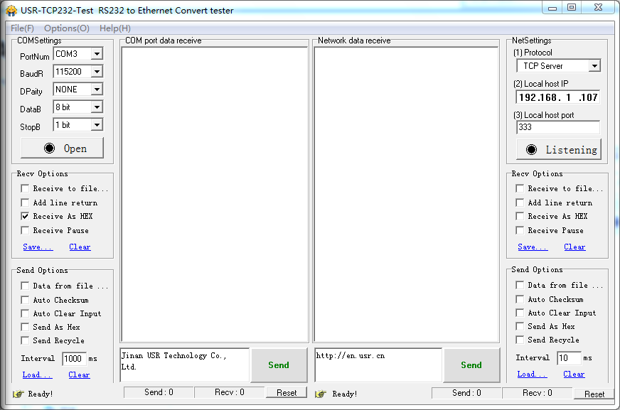
Set the proper serial port and then configure the network. Choose “TCP Client” in the Local host IP at the up-right corner; enter the assigned IP in Server IP; enter “333” as the Server Port.
To realize receiving and sending data, click Open the serial port on the left side of USR-TCP232-test and the Connect on the right side.

4. FAQ
The module will get slightly warm while working, it’s completely normal.

5. Schematic Diagram
